LANDIS-II v

Extension User Guide

Robert M. Scheller

Melissa S. Lucash

Megan Creutzburg

E. Louise Loudermilk

Portland State University

Last Revised: September 6, 2016

# Table of Contents

1 Introduction 4

1.1 Cohort Reproduction – Probability of Establishment 4

1.2 Cohort Growth 4

1.3 Soil and Dead Biomass Decay 5

1.4 Initializing Biomass and Soil Properties 5

1.5 Interactions with Disturbances 6

1.6 Available Light 6

1.7 Cohort Reproduction – Disturbance Interactions 6

1.8 Cohort Reproduction – Initial Biomass 6

1.9 Cohort Senescence and Mortality 6

1.10 Major Releases 7

1.10.1 Version 4.0 7

1.10.2 Version 3.1 8

1.10.3 Version 3.0 8

1.10.4 Version 2.0 11

1.11 Minor Releases 11

1.11.1 Version 4.0.2 11

1.11.2 Version 4.0.1 11

1.11.3 Version 3.1.1 11

1.12 References 11

1.13 Acknowledgments 13

2 Succession Input File 14

2.1 LandisData 14

2.2 Timestep 14

2.3 SeedingAlgorithm 14

2.4 InitialCommunities 14

2.5 InitialCommunitiesMap 14

2.6 ClimateConfigFile 14

2.7 CalibrateMode 15

2.8 SpinupMortalityFraction 15

2.9 Water Decay Function 15

2.10 Probability of Establishment Adjustment 15

2.11 ANPPMapNames 15

2.12 ANEEMapNames 16

2.13 SoilCarbonMapNames 16

2.14 SoilNitrogenMapNames 16

2.15 AvailableLightBiomass Table 16

2.15.1 First Row – Ecoregions 16

2.15.2 Available Light Class 17

2.15.3 Relative Biomass per Ecoregion 17

2.16 LightEstablishmentTable 17

2.16.1 Species Shade Tolerance Class 17

2.16.2 Probability of Establishment, given light conditions 17

2.17 SpeciesParameters Table 18

2.17.1 Species 18

2.17.2 Functional Type 18

2.17.3 Nitrogen Fixers 18

2.17.4 GDD minimum/maximum 18

2.17.5 Minimum January Temperature 18

2.17.6 Maximum Allowable Drought 18

2.17.7 Leaf Longevity 18

2.17.8 Epicormic resprouting 19

2.17.9 Lignin: Leaf, Fine Root, Wood, Coarse Root 19

2.17.10 CN Ratios: Leaf, Fine Root, Wood, Coarse Root, Litter 19

2.18 Functional Group Parameters 19

2.18.1 Name 19

2.18.2 Functional Type 19

2.18.3 PPDF: 1, 2, 3, 4 19

2.18.4 FRACleaf 20

2.18.5 BTOLAI, KLAI, MAXLAI 20

2.18.6 PPRPTS2, PPRPTS3 20

2.18.7 Woody Decay Rate 21

2.18.8 Monthly Wood Mortality 21

2.18.9 Mortality Curve – Shape Parameter 21

2.18.10 Leaf Drop Month 21

2.18.11 Coarse Root Fraction and Fine Root Fraction 21

2.19 Initial Ecoregion Parameters 22

2.19.1 Ecoregion Names 22

2.19.2 SOM1–3 Carbon and Nitrogen 22

2.19.3 Mineral Nitrogen 22

2.20 Ecoregion Parameters 22

2.20.1 Ecoregion Names 22

2.20.2 Soil Depth 22

2.20.3 Percent Clay, Percent Sand 23

2.20.4 Field Capacity, Wilting Point 23

2.20.5 Storm Flow Fraction, Base Flow Fraction, Drain 23

2.20.6 Nitrogen Inputs- Slope, Intercept 23

2.20.7 Latitude 23

2.20.8 Decay Rates of SOM1 surface, SOM1 soil, SOM2 and SOM3 24

2.20.9 N volatilization and Denitrification 24

2.21 Fire Reduction Parameters 24

2.21.1 Fire Severity 24

2.21.2 Wood Reduction 24

2.21.3 Litter Reduction 25

2.22 Harvest Reduction Parameters 25

2.22.1 Prescription Name 25

2.22.2 Wood Reduction 25

2.22.3 Litter Reduction 25

2.23 Ecoregion-dependent Species Parameters 25

2.23.1 First Row – Ecoregions 26

2.23.2 Other Rows – Species Parameters 26

2.23.3 MaximumMonthlyANPP Table 26

2.23.4 MaximumBiomass Table 27

2.24 AgeOnlyDisturbances:BiomassParameters 27

3 Output Files 28

4 Initial Communities Input File 29

4.1 Example File 29

4.2 LandisData 30

4.3 Initial Community Class Definitions 30

4.3.1 MapCode 30

4.3.2 Species Present 30

4.3.3 Grouping Species Ages into Cohorts 30

5 Input File – Age-only Disturbances 32

5.1 LandisData 32

5.2 CohortBiomassReductions Table 32

5.2.1 Disturbance 32

5.2.2 Woody 32

5.2.3 Non-Woody 33

5.3 DeadPoolReductions Table 33

5.3.1 Disturbance 33

5.3.2 Woody 33

5.3.3 Non-Woody 33

6 Example Inputs 1

6.1 Main Parameter File 1

6.2 Age-only Disturbances 5

# Introduction

This document describes the extension for the LANDIS-II model. For information about the LANDIS-II model and its core concepts including succession, see the *LANDIS‑II Conceptual Model Description* and the LANDIS-II website (www.landis-ii.org)*.*

The Century Succession Extension is a hybrid between the Century soil model (Parton et al. 1993, Schimel et al. 1994, Parton et al. 1994, Pan et al. 1998) and the LANDIS-II Biomass Succession extension (Scheller and Mladenoff 2004). Century Succession calculates how cohorts grow, reproduce, age, and die (Scheller et al. 2011). Dead biomass is tracked over time, divided into four pools: surface wood, soil wood (dead coarse roots), surface litter (dead leaves), and soil litter (dead fine roots). In addition, three principle soil pools: fast (soil organic matter (SOM) 1), slow (SOM2), and passive (SOM3) are simulated.

For a schematic drawing of the CENTURY extension, see Scheller et al 2011.

## Cohort Reproduction – Probability of Establishment

The probability of establishment (PEST) is internally calculated at an annual time step and is dependent upon input weather data. Although calculated annually, establishment can only occur following a disturbance or at a succession time step. PEST is based on the minimum of three limiting factors: 1) growing degree days (GDD), 2) drought tolerance, 3) minimum January temperature. These represent **ecoregion-scale** limits to species establishment in that the requisite parameters vary by ecoregion. Available light is calculated as in Biomass Succession (v2) and is included as a part of the **site scale** limits to establishment.

To determine whether reproduction takes place at a sucession time step, the model first checks the site-scale limits to reproduction. If this test is passed, ecoregion-scale limits are checked next. If successful, the site and landscape are searched for propagules as in all previous succession extensions.

## Cohort Growth

At each time step, cohort growth is determined by estimated leaf area index (LAI), water availability, temperature, growing space capacity and nitrogen availability. Cohort growth generally follows the algorithms found in Century, except for N uptake. In the spring, the amount of resorbed N is calculated (leaf N - litter N), which can be “used” by the cohort when conditions are conducive to growth. In hardwoods, resorbed N is used primarily in the spring; resorbed N can be utilized throughout the year in conifers. After the pool of resorbed N is depleted, the cohort takes up N from the mineral N pool. Uptake of N is proportional to above-ground net primary productivity (ANPP), with greater N uptake by faster growing cohorts. When mineral N is limiting, competition for N between cohorts is determined by the relative amount of their coarse root biomass.

## Soil and Dead Biomass Decay

All soil processes follow the algorithm and science from Century v4.5 whereby there are four litter pools (structural and metabolic material either on the surface or within the soil) and three soil organic matter (SOM) pools (SOM 1,2,3). SOM1 is further subdivided into SOM1 surface and SOM1 soil.

Decay rates of SOMsurf, SOM1soil, SOM 2 and SOM 3 are user inputs at the **ecoregion** scale.

## Initializing Biomass and Soil Properties

The initial biomass is estimated as in the Biomass Succession extensions during model “spin-up”. **The user does not supply the initial biomass estimates.** The Century Succession extension iterates the number of time steps equal to the maximum cohort age for each site. Beginning at time (t - oldest cohort age), cohorts are added at each time step corresponding to the time when the existing cohorts were established. Next, each cohort undergoes growth and mortality for the number of years equal to its current age. Initial cohort biomass therefore reflects competition among cohorts. Likewise, beginning with initial soil values, the dead and SOM pools change during the spin-up phase.

**Note:** *An initial (time zero) climate stream is required for initialization (see the climate library user’s manual- LANDIS-II Climate Library v1.0 User Guide).*

This initialization does not account for disturbances and therefore typically overestimates initial live biomass and underestimates initial dead biomass quantities.

**Note**: *Required computation time reflects the number of initial communities listed in the initial community file.*

## Interactions with Disturbances

Century Succession was written to allow disturbances (e.g. wind and harvest) that operate on age-only cohorts to interact with the two dead biomass pools. For example, a User is able to run the wind extension with Century Succession. Although the wind disturbance extension is not ‘biomass aware’, a simple interface was created that enables the biomass of cohorts killed by the disturbance to be allocated to the proper dead biomass pools. The interface allows a user to indicate a) whether and how much leaf or woody **live biomass** is transferred to their respective dead pools by a disturbance type and b) whether and how much of the leaf or woody **dead biomass *aboveground* pools** are removed by a disturbance type.

**Note**: *Do not list fire in the age-only disturbance table*. Fire effects vary by severity and are indicated in the separate **FireReductionParameters** table (below).

This interface does not allow dynamic changes in the transfer rates into and out of the dead pools. Rather, the interface was designed to allow existing age-cohort disturbances to be used with Century Succession.

The interface is specified in a separate LandisData parameter file: "Age-only Disturbances - Biomass Parameters". See Chapter 4.

## Available Light

Available light (the conceptual inverse of shade) calculations follow the shade algorithms in Biomass Succession (v2).

## Cohort Reproduction – Disturbance Interactions

See the rules and algorithm outlined for Biomass Succession (v2).

## Cohort Reproduction – Initial Biomass

See the rules and algorithm outlined for Biomass Succession (v2).

## Cohort Senescence and Mortality

See the rules and algorithm outlined for Biomass Succession (v2).

## Major Releases

### Version 4.0

In version 4.0,we added a climate library to the Century extension to enable a suite of LANDIS-II model extensions to use the same stream of climate data (see the climate library user’s manual (LANDIS-II Climate Library v1.0 User Guide). By only feeding in climate data only once, the climate is seamlessly integrated across all extensions specified in the scenario file. As outlined in the climate library user’s guide, the user can feed in daily or monthly data without having to calculate standard deviation like in Century version 3.1 or earlier.

In this version, we significantly revised the soil water algorithms, correcting errors in the timing of snowfall, snowmelt, runoff and available water.

We modified retranslocation for conifers so that they could utilized the resorbed N throughout the year. In previous versions, conifers were restricted to using resorbed N in the spring (like hardwoods), but in this version, conifers are able to use this N source whenever tree growth is occurring.

We modified the calibrate mode so that it runs from July to June, the same way the model normally runs (see Section 1.10.4). In previous versions of Century, the calibrate mode ran from Jan to Dec.

We also corrected several minor errors. We corrected an error in units, which was causing baseflow to be an order of magnitude higher than the stormflow in previous versions of Century. We corrected an error in the calibration mode that cause the trees to grow faster than in normal mode. We modified LAI so that it was set to zero in hardwoods when leaf drop occurred and modified the BTOLAI and KLAI parameters to make them easier to calibrate. Finally, we corrected an error in the N intercept parameter, which was not being used in the calculation of N deposition. Now both the N slope and intercept parameters can influence N deposition to account for wet (slope) and dry (intercept) deposition.

Finally, we increased the range of soil organic matter inputs to account for the large amount of carbon stored in productive forests, like in the Pacific Northwest. We also reduced the minimum fraction of leaf biomass (Fcfrac) allowed in the input file to account for the small ratio of leaf: wood biomass in these forests.

### Version 3.1

We fixed frass N, which was artificially creating large increases in mineral N during defoliation events when Century was run with the Leaf Biomass Insects Extension. Now when insect defoliation occurs, there is a small increase in frass N that corresponds to values observed in the field.

In the Century output table, we redefined the soil N pool by removing the surficial dead wood and soil dead wood. This makes the soil N pool consistent with the soil C pool, which doesn’t include dead material.

We also adjusted the mineral N so that it can not be depleted to zero, which caused errors for N uptake until more N deposition occurred. Now mineral N can be very small (<0.01) but not zero, allowing the calculation of N uptake even when the rates are very low.

### Version 3.0

In this version of Century, we made major improvements to **nitrogen cycling**, made minor changes to **belowground productivity**, **probability of establishment**, and added an **output file** that is generated when Century is run in calibrate mode.

Nitrogen cycling in previous versions of Century Succession focused primarily on how N regulates C cycling, rather than describing N dynamics, per se.

In version 3.0, total nitrogen, (NH4+, NO3-, and organic N), is now fully integrated throughout the extension with all the major inputs (deposition, N-fixation, insect frass), outputs (leaching and volatilization) and fluxes (resorption, litterfall, uptake, decomposition) simulated within the extension. This allows users to track C and N cycling in their landscape and better understand the relative importance of N in regulating productivity.

Specifically, we added N resorption, the amount of N withdrawn from the leaves just prior to senescence. Retranslocation is a significant source of N uptake in the spring and can be 10-80% of N uptake depending on species, site and the time since disturbance (Killingbeck 1996, Covelo et al. 2008). Retranslocation for each cohort is calculated in August of each year as the difference between leaf and litter N, and is used the following spring to satisfy the cohorts’ early demand for N. After the resorptive pool is depleted, the cohort satisfies its need for N by withdrawing N from the soil (i.e. mineral N).

We also added insect frass to the C and N budget. Most large insect outbreaks occur in the summer before retranslocation occurs, causing a significant decline in the ability of trees to resorb N and potentially decreasing growth the following spring (Lovett et al. 2002). The addition of C and N in frass can cause changes in decomposition rates, which may affect long-term nutrient availability and productivity. In the extension, defoliation events trigger deposition of frass C and N deposition, the relative amount of which is a function of the amount of leaf biomass removed during defoliation. Since C/N ratio of frass (C/N =23 from Lovett and Ruesink, 1995) may differ from litterfall, frass can also cause changes in the decomposition rates of the soil pools that can affect long-term carbon cycling and productivity.

We added N leaching which is a function of soil texture, the amount of available mineral N and the relative rates of base and storm flow. The calculations are based on the original CENTURY model by Parton et al. (1983), though modified so that only NO3- (and not total N) is leached from soils. The direct loss of mineral N to the atmosphere – not dependent upon fire as an agent - was modified so that the relative amount can vary with different ecosystems within the landscape. The relative amount of N loss through ammonia volatilization and denitrification is now an input parameter for each ecoregion. This is particularly useful when the landscape includes both uplands and wetlands, since wetlands have a much higher denitrification rates than uplands (Seitzinger et al. 2006). Overall, ammonia volatilization is relatively low (<0.1 g m-2 y-1) from unfertilized forest ecosystems (Schlesinger and Hartley 1992), but denitrification rates can be significant, especially in forested wetlands (0.8 g m-2 y-1, (Seitzinger et al. 2006).

We modified how N limits aboveground productivity, switching from a categorical (i.e. N tolerance) to a more process-based approach. When N is limiting, mineral N is allocated between cohorts based on their biomass (i.e. coarse root biomass). This value is divided by the N demand for each cohort (amount of N needed for growth) to get a relative index (0-1) of how much N is limiting growth for that cohort.

N limitation = N allocation / N demand equation 1

We added input parameters for the decay rates of the fast-cycling soil pool so the user can better regulate the respiration and N mineralization rates of the SOM1surf and SOM1soil pools. The decay constants of all three soil pools (fast, slow and passive) can now be adjusted to ensure that the relative decomposition rates between pools are realistic and reflect the expected annual changes in each pool.

We modified the relationship between **belowground** and aboveground **productivity**, based on new studies (Albaugh et al. 2006, Park et al. 2008). We increased belowground productivity, such that fine root biomass is now 75% of leaf biomass (was 70% in v2) and coarse root biomass is 50% (rather than 30%) of wood biomass.

We added an input parameter that adjusts the **probability of establishment** based on the time step you specify in Century. This allows users to account for differences in establishment depending on the succession timestep. The expectation is that shorter time steps will have smaller PEST. For example, if you were operating at a 5-year time step and you decided to step it down to a 1-year time step, the adjustment factor of 0.2 should be applied to arrive at equivalent PEST.

We also added a new **output file** that is generated when Century is run in calibrate mode. This output file allows the user to (among other things) determine what is limiting growth of each cohort at each time step.

We added a new **optional** parameter table that can be used in conjunction with the Leaf Biomass Harvest extension (see “LANDIS-II Leaf Biomass Harvest v2.0 User Guide”). This table indicates the proportion of dead wood and leaf biomass that should be removed as a function of a specific harvest activity. The dead biomass includes cohorts killed from the harvest activity and dead biomass (e.g., coarse woody debris, leaf litter) already present in the forest. **If this table is not used, the harvested cohorts will be follow the parameters in the age-only-disturbance file (see below).** This table may be used if, for example, after a harvest event, a controlled burn would be applied to a stand to remove a proportion of leaf litter and coarse woody debris. *If the table is used be sure to remove harvesting from the age-only-disturbance file.*

### Version 2.0

Century Succession is now compatible with LANDIS-II v6.0. All succession extensions for v6.0 are required to include the initial communities text file and inputs map. Previously these were input in the **Scenario** file. These details are outlined below. Internal Time Steps

Although the Century Succession is limited to annual or multiple-year time steps, **cohort growth and soil decomposition operate at a monthly time step**. Both growth and decomposition reflect monthly climate and monthly climate is a required input.

Because most disturbances occur in the summer months, the monthly cycle proceeds from July to June. Therefore, **disturbances and reproduction both occur between June and July**.

## Minor Releases

### Version 4.0.2

In version 4.0.2,we fixed a bug that was caused Century to crash when it was run with harvesting due to a conflict between reseeding and planting. We also fixed a bug in PET that was preventing winter respiration. We reduced the acceptable range of values for field capacity and wilting point.

### Version 4.0.1

In version 4.0.1,we fixed a bug that was causing Century to ignore the timestep specified in the input file and using the timestep supplied by Dynamic Fire. This was only an issue when both Century and Dynamic Fir were enabled in the scenario fire.

### Version 3.1.1

We eliminated the ClimateChangeTable in the Century input file. It was not used to calculate ANPP in versions 3.0 or 3.1, so it was removed from the code to eliminate any confusion.

## References

Aber, J.D., D.B. Botkin, and J.M. Melillo. 1979. Predicting the effects of different harvesting regimes on productivity and yield in northern hardwoods. Canadian Journal of Forest Research **9**: 10-14.

Albaugh, T., H. Allen, and L. Kress. 2006. Root and stem partitioning of *Pinus taeda*. Trees - Structure and Function 20:176-185.

Botkin, D.B., J.F. Janak, and J.R. Wallis. 1973. Some ecological consequences of a computer model of forest growth. Journal of Ecology **60**: 849-872

Covelo, F., J. Duran, and A. Gallardo. 2008. Leaf resorption efficiency and proficiency in a *Quercus robur* population following forest harvest. Forest Ecology and Management.

Johnson, D. W., M. E. Fenn, W. W. Miller, and C. T. Hunsaker. 2009. Fire effects on carbon and nitrogen cycling in forests of the Sierra Nevada. Pages 405-423 in A. Bytnerowicz, M. Arbaugh, C. Andersen, and A. Riebau, editors. Wildland Fires and Air Pollution. Developments in Environmental Science 8. Elsevier, The Netherlands.

Killingbeck, K. T. 1996. Nutrients in senesced leaves: Keys to the search for potential resorption and resorption proficiency. Ecology 77:1716-1727.

Lovett, G. M., L. M. Christenson, P. M. Groffman, C. G. Jones, J. E. Hart, and M. J. Mitchell. 2002. Insect defoliation and nitrogen cycling in forests. BioScience 52:335-341.

Lovett, G. M. and A. E. Ruesink. 1995. Carbon and nitrogen mineralization from decomposing gypsy moth frass. Oecologia 104:133-138.

Kimmins, J. P., D. Mailly, and B. Seely. 1999. Modelling forest ecosystem net primary production: the hybrid simulation approach used in FORECAST. Ecological Modelling 122:195-224.

Pan, Y., J.M. Melillo, A.D. McGuire, D.W. Kicklighter, L.F. Pitelka, K. Hibbard, L.L. Pierce, S.W. Running, D.S. Ojima, W.J. Parton, D.S. Schimel, and VEMAP Members. 1998. Modeled responses of terrestrial ecosystems to elevated atmospheric CO2: a comparison of simulations by the biogeochemistry models of the Vegetation /Ecosystem Modeling and Analysis Project (VEMAP). Oecologia 114: 389-404.

Park, B., R. Yanai, T. Fahey, S. Bailey, T. Siccama, J. Shanley, and N. Cleavitt. 2008. Fine root dynamics and forest production across a calcium gradient in northern hardwood and conifer ecosystems. Ecosystems 11:325-341.

Parton, W. J., D. S. Ojima, C. V. Cole, and D. S. Schimel. 1994. "A General Model for Soil Organic Matters Dynamics: Sensitivity to Litter Chemistry, Texture and Management." Pp. 147-67 in Quantitative Modeling of Soil Forming Processes: Proceedings of a Symposium Sponsored by Divisions S-5 and S-9 of the Soil Science Society of America Minneapolis, Minnesota, USA, editors R. B. Bryant and R. W. Arnold. Madison, Wisconsin, USA: Soil Science Society of America.

Parton, W.J., J.M.O. Scurlock, D.S. Ojima, T.G. Gilmanov, R.J. Scholes, D.S. Schimel, T. Kirchner, J.C. Menaut, T. Seastedt, E. Garcia Moya, A. Kamnalrut, and J.I. Kinyamario. 1993. Observations and modeling of biomass and soil organic matter dynamics for the grassland biome worldwide. Global Biogeochemical Cycles 7: 785-809.

Ryan, D. F. and F. H. Bormann. 1982. Nutrient resorption in northern hardwood forests. BioScience 32:29-32.

Scheller, R. M., D. Hua, P. V. Bolstad, R. A. Birdsey, and D. J. Mladenoff. 2011. The effects of forest harvest intensity in combination with wind disturbance on carbon dynamics in Lake States mesic forests. Ecological Modelling 222:144-153.

Scheller, R.M., S. Van Tuyl, K. Clark, J. Hom, I. La Puma. 2011. Carbon sequestration in the in the New Jersey pine barrens under different scenarios of fire management. Ecosystems. DOI: 10.1007/s10021-011-9462-6

Scheller, R. M. and Mladenoff, D. J. A forest growth and biomass module for a landscape simulation model, LANDIS: Design, validation, and application. Ecological Modelling. 2004; 180(1):211-229.

Schimel, D.S., B.H. Braswell, E.A. Holland, R. McKeown, D.S. Ojima, T.H. Painter, W.J. Parton, and A.R. Townsend. 1994. Climatic, edaphic, and biotic controls over storage and turnover of carbon in soils. Global Biogeochemical Cycles 8: 279-293.

Seitzinger, S., J. A. Harrison, J. K. Böhlke, A. F. Bouwman, R. Lowrance, B. Peterson, C. Tobias, and G. V. Drecht. 2006. Denitrification across landscapes and waterscapes: A synthesis. Ecological Applications 16:2064-2090.

Schlesinger, W. H. and A. E. Hartley. 1992. A global budget for atmospheric NH3. Biogeochemistry 15:191-211.

## Acknowledgments

Funding for the development of LANDIS-II has been provided by the Climate Change Program (New Town Square, Pennsylvania) of the U.S. Forest Service. Funding for Century version 3.2 has been provided by USDA AFRI.

# Succession Input File

Nearly all the input parameters for this extension are specified in one main input file. This text file must comply with the general format requirements described in section 3.1 *Text Input Files* in the *LANDIS‑II Model User Guide*.

## LandisData

This parameter’s value must be "Century Succession".

## Timestep

This parameter is the time step of the extension. Value: integer > 0. Units: years.

**Note**: When changing the timestep of this extension (e.g., from a 5-year time step to a 1-year time step), you may need to adjust the probability of establishment adjustment factor (ProbEstablishAdjust) to retain the same regeneration rates (see section 2.13 below).

## SeedingAlgorithm

This parameter is the seeding algorithm to be used. Valid values are "WardSeedDispersal", "NoDispersal" or "UniversalDispersal". The algorithms are described in section 4.5.1 *Seeding* of the *LANDIS‑II Conceptual Model Description*.

## InitialCommunities

This parameter is the file with the definitions of the initial communities at the active sites on the landscape (see section 4).

## InitialCommunitiesMap

This parameter is the input map indicating the initial communities at the active sites on the landscape. Each cell value for an active site on the landscape must be one of the map codes listed in the initial communities input file (see section 4).

## ClimateConfigFile

The climate configuration file contains required climatic inputs. The format of that file and its contents are described in the climate library user’s manual (LANDIS-II Climate Library v1.0 User Guide).

## SoilDrainMapName

Soil drain (0.0 – 1.0) determines any anaerobic effect via the corresponding function:

CalculateAnaerobicEffect(drain, ratioPrecipPET, pet, tave);

The higher the value, the less saturated the soil and the anaerobic effect is reduced.

## SoilStormFlowMapName

If there is excess water, greater than field capacity, a fraction is storm flow (Storm Flow fraction: 0.0 – 1.0), which is associated with leaching of C and N. The remaining water is disregarded and does not leach.

## SoilBaseFlowMapName

A fraction of soil water (Base Flow fraction: 0.0 – 1.0) is lost every month due to leaching into the ground water. This fraction is determined by the Base Flow fraction.

## CalibrateMode

Determines whether the model is run in calibrate mode whereby additional parameters are added to a log file (“Century-calibrate-log.csv”). **The calibrate mode should only be used when simulating a single site due to the volume of screen output.** The intention is to view output of additional parameters, such as what factors are limiting growth at each time step.

## SpinupMortalityFraction

Determines the fraction of mortality that occurs during initialization/ model spin-up. This can be adjusted to account for the mortality that would occur during model initialization (see section 1.4).

## Water Decay Function

The WaterDecayFunction parameter determines the effect of moisture on decay rate can be either linear or based on a ratio. The Century 4.0 Help file states that linear option is to be when only the relative water content in the top 15 cm affects decay rates. If ratio, the ratio of rainfall to potential evaporation rate determines the effect of moisture on decay rates.

Options: “Linear” or “Ratio”

***User Tip:*** Linear is generally appropriate for sandy soils; ratio for more mesic soils.

## Probability of Establishment Adjustment

This optional parameter adjusts the probability of establishment. The default value is one.

***User Tip:*** This value can be reduced (<1) if regeneration rates are too high. This is particularly useful when changing the successional time step- e.g. changing from a 5-year time step to a 1-year time step. For example, if you want regeneration at a 1-year successional time step to be equivalent to 5-year time step values, a value of 0.2 (1/5) would be most appropriate when using a 1-year time step.

## ANPPMapNames

This **optional** file parameter is the template for the names of the ANPP output maps. The parameter value must include the variable “timestep” to ensure that the maps have unique names (see Section 3.1.8.1 *Variables* in the *LANDIS-II Model User Guide*). **The user must indicate if the output should be placed in a sub-directory and must indicate the file extension.** The output map units are g C m-2.

In addition, an ANPPMapFrequency parameter must follow the ANPPMapNames parameter on the next line. This parameter value must be a valid time step (see Section 2.2). This parameter defines the frequency in which the maps are output, e.g., if your model Timestep is 5, then the ANPPMapFrequency value could be 5, 10, 15, etc.

## ANEEMapNames

This **optional** file parameter is the template for the names of the ANEE (Annual Net Ecosystem Exchange) output maps. The parameter value and map frequency is created identically to ANPPMapNames and ANPPMapFrequency (see Section 2.9).

## SoilCarbonMapNames

This **optional** file parameter is the template for the names of the soil carbon output maps. The parameter value and map frequency is created identically to ANPPMapNames and ANPPMapFrequency (see Section 2.9).

## SoilNitrogenMapNames

This **optional** file parameter is the template for the names of the soil nitrogen output maps. The parameter value and map frequency is created identically to ANPPMapNames and ANPPMapFrequency (see Section 2.9). The output map units are g N m-2.

## AvailableLightBiomass Table

The AvailableLightBiomass table defines how much biomass must be at a site to achieve the five available light classes (in previous extensions, ‘shade classes’). Biomass is not absolute but relative to the maximum biomass possible at a site. The table contains the relative biomass required for each available light class, 1 - 5.

### First Row – Ecoregions

The first row in the table is a list of all the active ecoregions defined in the ecoregions input file (see chapter 6 in the *LANDIS‑II Model User Guide*. The ecoregions can appear in any order; they do not need to appear in the same order as in the ecoregions input file.

### Available Light Class

This column contains available light class values: 1 ≤ integer ≤ 5. The classes must be in increasing order: class 1 first and ending with class 5. Available light class 5 represents the least light (most shade). A site will be class 0 (complete light) if relative biomass ranges from 0% of maximum up to the relative biomass (%) for class 1. Likewise, if relative biomass is between the amount defined for classes 1 and 2, the site is given an available light class of 1. And so on up to class 5.

### Relative Biomass per Ecoregion

Each ecoregion listed in the table’s first row (see section 2.15.1) must have a separate column of minimum relative biomass by available light class. The percentages represent the lower threshold of biomass on a site relative to the ecoregion’s maximum possible biomass (for any species) for the site to enter the shade class indicated in column 1. Value: 0.0 ≤ decimal number ≤ 100.0. Units: percent.

## LightEstablishmentTable

This table allows the user to control site-scale PEST dependent upon species light requirements (i.e., shade class) and available light. For example, if a species is mid-tolerant of low light (light requirement = 3) and the available light class is 5 (very low light), the probability may be low but not zero. If the user indicates a low probability, then there would still some small chance that a mid-tolerant can become established as may be the case in small gaps.

### Species Shade Tolerance Class

This column contains light requirement (shade) class values: 1 ≤ integer ≤ 5. The classes must be in increasing order: class 1 first and ending with class 5. Class 5 represents species with the lowest light requirements, i.e., the most shade tolerant.

### Probability of Establishment, given light conditions

Each possible site-level light condition (0 – 6) has an associated probability for each species light requirement class (1 – 5). Value: 0.0 ≤ decimal number ≤ 1.0.

## SpeciesParameters Table

This table contains species’ physiological parameters. Each row in the table has the parameters for one species. Every active species must have an entry.

### Species

The species must be defined in the species input file (see chapter 5 in the *LANDIS‑II Model User Guide*). Species may appear in any order.

### Functional Type

This is an index into the FunctionalTypeParameters table, below.

### Nitrogen Fixers

This should be either yes (Y) or no (N), depending on whether the species can fix N.

### GDD minimum/maximum

Growing Degree Day (GDD) maximum and minimum are used to define a species climatic envelope following the algorithm by Botkin (1973). GDD is calculated on a 5°C base.

### Minimum January Temperature

A species has a minimum tolerable January temperature (the mean of January nights). If the stochastically generated January minimum temperature is below the minimum, a species cannot establish. Units: degrees Celsius.

### Maximum Allowable Drought

If available water falls below zero for a percent of the growing season greater than this value, a species cannot establish. Units: fraction of the growing season (0.0 – 1.0). Lower values indicate species whose establishment is more sensitive to drought.

### Leaf Longevity

This parameter is the average longevity of a leaf or needle. Value: 1.0 ≤ decimal number ≤ 10.0. Units: years.

### Epicormic resprouting

Does the species resprout via epicormic branching following a fire? Value: Y/N; yes, no.

### Lignin: Leaf, Fine Root, Wood, Coarse Root

The fraction of lignin in each plant component (leaf, fine root, wood, and coarse root) per species. Value: 0.0 ≤ decimal number ≤ 1.0.

### CN Ratios: Leaf, Fine Root, Wood, Coarse Root, Litter

The carbon to nitrogen ratios for leaf, fine root, wood, coarse root, and litter components. The difference between leaf and litter CN ratios represents the amount of N that is resorbed (i.e. retranslocated) prior to leaf mortality.

**Note**: *For retranslocation to work properly, litter CN* ***must be*** *higher than leaf CN for each species.*

## Functional Group Parameters

These parameters are either not generally resolved to the level of species or are similar across genera. **The number of functional groups cannot exceed 25.**

### Name

The name is for display purposes only to help users organize the inputs.

### Functional Type

An index to the species table.

### PPDF: 1, 2, 3, 4

* These four parameters define a temperature growth curve. ppdf(1)- optimum temperature for production for parameterization of a Poisson Density Function curve to simulate temperature effect on growth
* ppdf(2) - maximum temperature for production for parameterization of a Poisson Density Function curve to simulate temperature effect on growth
* ppdf(3) - left curve shape for parameterization of a Poisson Density Function curve to simulate temperature effect on growth
* ppdf(4) - right curve shape for parameterization of a Poisson Density Function curve to simulate temperature effect on growth

For a more detailed explanation of these parameters, see the CENTURY 4.5 manual and help files (<http://www.nrel.colostate.edu/projects/century/manual4/man96.html>).

### FRACleaf

The fraction of aboveground net primary productivity that is allocated to leaves. Units: fraction of ANPP (0.0 – 1.0).

### BTOLAI, KLAI, MAXLAI

These three parameters determine how LAI is calculated which subsequently limits growth. Therefore these parameters help determine the initial rate of growth in the landscape. BTOLAI - biomass to leaf area index (LAI) conversion factor for trees

* KLAI - large wood mass (g C/m2) at which half of theoretical maximum leaf area [(maxlai)](http://www.nrel.colostate.edu/projects/century/manual4/man96.html#MAXLAI) is achieved
* MAXLAI - theoretical maximum leaf area index achieved in a mature forest

For definitions, see the Century 4.5 on-line manual (http://www.nrel.colostate.edu/projects/century/manual4/man96.html). BTOLAI determines LAI as a function of leaf biomass. KLAI and MAXLAI determine LAI as a function of wood biomass. If MAXLAI = 0.0, then only leaf biomass determines LAI and the growth limits.

For a more detailed explanation of these parameters, see the CENTURY 4.5 manual and help files (<http://www.nrel.colostate.edu/projects/century/manual4/man96.html>).

### PPRPTS2, PPRPTS3

* These two parameters determine growth sensitivity to low available water, e.g., drought conditions. pprpts(2) - the effect of water content on the intercept
* pprpts(3)- the lowest ratio of available water to [potential](http://www.nrel.colostate.edu/projects/century/manual4/man96.html#PET) evapotranspiration at which there is no restriction on production

For a more detailed explanation of these parameters, see the CENTURY 4.5 manual and help files (<http://www.nrel.colostate.edu/projects/century/manual4/man96.html>).

### Woody Decay Rate

This parameter defines the maximum fraction of the species’ dead wood that decomposes in the ecoregion. Value: 0.0 ≤ number ≤ 1.0. Unitless.

### Monthly Wood Mortality

A monthly fraction of wood mortality. This replaces the algorithm in Biomass Succession v2 where growth-related mortality was a function of ANPP. Units: fraction of wood biomass (0.0 – 1.0).

**User Tip**: *This parameter can have large effects. If set too high, a site can remain in a permanent ‘juvenile’ state and dead woody biomass and SOM will increase very quickly and reach overly high levels. If too low, the site will reach maximum biomass too quickly and SOM may actually decline.*

### Mortality Curve – Shape Parameter

This parameter determines how quickly age-related mortality begins and operates as in Biomass Succession v1 and v2. Value: 5.0 ≤ decimal number ≤ 25.0. If the parameter = 5, then age-related mortality will begin at 10% of life span. If the parameter = 25, then age-related mortality will begin at 85% of life span.

### Leaf Drop Month

This parameter determines when the leaves will drop and become part of the litter pool.

**Note:** *Note that LeafDropMonth=9 means that leaves will drop in August (one month offset).*

### Coarse Root Fraction and Fine Root Fraction

The fraction of aboveground net primary productivity that is allocated to coarse roots and fine roots. Units: fraction of ANPP (0.0 – 1.0).

## Initial Ecoregion Parameters

The initial ecoregion parameters allow soils to begin with some C and N. However, SOM C and N at time zero will also reflect the initial communities and ecoregion parameters (e.g., soil depth, field capacity, wilting point).

**Note**: *Dead biomass (wood, structural, and metabolic) is estimated from the growth and mortality of cohorts during initialization.*

### Ecoregion Names

The first column in the table is a list of one or more active ecoregions defined in the ecoregions input file (see chapter 6 in the *LANDIS‑II Model User Guide*). The ecoregions can appear in any order; they do not need to appear in the same order as in the ecoregions input file.

### SOM1–3 Carbon and Nitrogen

The initial amount of C and N in the four principle soil pools: SOM1-surface, SOM1-soil, SOM2 and SOM3. Units: g C m-2 and g N m-2.

### Mineral Nitrogen

The initial amount of mineral N. This N is available to plants for growth. Units: g m-2.

## Ecoregion Parameters

### Ecoregion Names

The first column in the table is a list of one or more active ecoregions defined in the ecoregions input file (see chapter 6 in the *LANDIS‑II Model User Guide*). The ecoregions can appear in any order; they do not need to appear in the same order as in the ecoregions input file.

### Soil Depth

The depth of the soil simulated, cm.

**User Tip:** The depth specified here will influence other ecoregion parameters in the table (e.g. % sand, % clay, field capacity). For example, if you choose a soil depth of 50cm, you might have lower % sand, than if you select a soil depth of 100cm.

### Percent Clay, Percent Sand

Units: fraction of soil (0.0 – 1.0).

### Field Capacity, Wilting Point

Field capacity and wilting point expressed as a fraction of the soil depth. In the model, field capacity and wilting point are calculated as this fraction multiplied by soil depth.

### Storm Flow Fraction, Base Flow Fraction, Drain

Determines the amount of water runoff and leaching. This affects the amount of N leaching (N loss) which, in turn, affects the amount of mineral N.

* drain - the fraction of excess water lost by drainage. The soil drainage factor allows a soil to have differing degrees of wetness (e.g., [DRAIN](http://www.nrel.colostate.edu/projects/century/manual4/man96.html#DRAIN)=1 for well drained sandy soils and [DRAIN](http://www.nrel.colostate.edu/projects/century/manual4/man96.html#DRAIN)=0 for a poorly drained clay soil).
* basef - fraction per month of subsoil water going into stream flow
* stormf - the fraction of the soil water content lost as fast stream flow

### Nitrogen Inputs- Slope, Intercept

Determines N deposition rates (both wet and dry deposition) using simple regression:

Total N deposition = (AtmosNslope*precipitation) + AtmosNinter

The AtmosNslope parameter controls how the amount of wet deposition, i.e. how much N is deposited during rain events, with higher slopes generating more N deposition. Dry deposition is controlled by the N intercept parameter, which is constant and is not a function of precipitation.

**User Tip:** *Adjust the slope and intercept until the monthly or annual N deposition in the century-succession-monthly-log.csv is similar to literature values.*

### Latitude

The latitude of the study site (°)

### Decay Rates of SOM1 surface, SOM1 soil, SOM2 and SOM3

The decay rates for SOM1-surface, SOM1-soil, SOM2, and SOM3 determine the **maximum** decomposition rate (k) of the four soil organic matter pools.

**User Tip:** *The decay rates should be adjusted to so that the changes in each of the soil pools between year 0 (input file) and year 1 are realistic. In most landscapes, the relative changes in the soil pools are higher in the upper than the lower horizons. Therefore, the maximum decay rates should be higher in the surficial than the deeper pools (i.e. DecayRateSurf>DecayRateSOM1> DecayRateSOM2>DecayRateSOM3). Also, the total amount of C in soil should slowly increase over time in the absence of disturbance.*

### N volatilization and Denitrification

The fraction of mineral N lost through ammonia volatilization and denitrification **per month**. This fraction is not fire related; fire related volatilization is modeled separately). Units: dimensionless.

**User Tip:** *This parameter should be adjusted so that Nvol (output parameter of N volatilization) ranges from 0 to ~0.3 for uplands and 0.3 to 1 g m-2 year-1 for wetlands (Seitzinger et al. 2006).*

## Fire Reduction Parameters

The FireReductionParameters table allows users to specify how much dead wood and litter will be removed as a function of fire severity. The reduction of wood and litter will occur **after** fire induced mortality of cohorts. After a fire kills a cohort, the dead biomass is deposited on the forest floor and is then subsequently volatilized in the same time step.

**Note**: This table is needed even if fire extensions are not being used.

### Fire Severity

The first column is fire severity, classes 1 – 5. Severity should be listed in ascending order.

### Wood Reduction

The second column is the proportion (0.0 – 1.0) of dead wood biomass that is volatilized. The proportion will be applied to both C and N components.

### Litter Reduction

The third column is the proportion (0.0 – 1.0) of dead litter biomass that is volatilized. The proportion will be applied to both C and N components.

## Harvest Reduction Parameters

The **optional** HarvestReductionParameters table allows users to specify how much dead wood and litter will be removed as a function of harvest activity. The reduction of wood and litter will occur **after** harvest induced mortality of cohorts. After a harvest event kills a cohort, the dead biomass is removed from the forest. **If this table is not used, the harvested cohorts will follow the parameters in the age-only-disturbance file (see below).** *If the table is used be sure to remove harvesting from the age-only-disturbance file.*

### Prescription Name

The first column is prescription name. Each prescription name must be identical to the prescription names in the Leaf Biomass Harvest file (see “LANDIS-II Base Harvest v2.0 User Guide”). Prescriptions can be in any order; they do *not* need to appear in the same order as in the Leaf Biomass Harvest input file.

### Wood Reduction

The second column is the proportion (0.0 – 1.0) of dead wood biomass that is removed. The proportion will be applied to both C and N components.

### Litter Reduction

The third column is the proportion (0.0 – 1.0) of dead litter biomass that is removed. The proportion will be applied to both C and N components.

## Ecoregion-dependent Species Parameters

The Century Succession extension uses some species parameters that vary by ecoregion:

* Maximum monthly aboveground net primary production (ANPP). Note this parameter is in units of biomass, not carbon (C). C generally comprises roughly 50% of biomass.
* Maximum above ground biomass (AGB). Note this parameter is in units of biomass, not carbon (C). C generally comprises roughly 50% of biomass.

Each parameter has its own table.

### First Row – Ecoregions

The first row in a table is a list of one or more active ecoregions defined in the ecoregions input file (see chapter 6 in the *LANDIS‑II Model User Guide*). The ecoregions can appear in any order; they do not need to appear in the same order as in the ecoregions input file.

Every active ecoregion that is not in a table’s first row will have default parameter values assigned to all the species (given below). The sections below which describe the individual parameter tables also specify the default value for each table.

### Other Rows – Species Parameters

All other rows in a table after the initial row contain species parameter values. Each row contains the parameter values for one species. The species name comes first, followed by one or more parameter values. The name and values are separated by whitespace. There must be one parameter value for each of the ecoregions listed in the table’s first row.

The species can be listed in any order in a table. A species can be omitted. If so, it will be assigned the default parameter value for all active ecoregions.

### MaximumMonthlyANPP Table

This parameter is the maximum possible aboveground net primary productivity (ANPP) for each cohort of each species in the ecoregion. The value is specified as the ANPP in the month of the year with maximum growth (e.g., June). Value: 0 ≤ integer ≤ 100,000. Units: g biomass m-2 month-1. Default value: 0

**Note:** This parameter is in units of biomass but output from Landis-Century is in units of C (C generally comprises roughly 50% of biomass. Also, remember that this is the maximum monthly ANPP during peak growing season, not the annual ANPP often reported in the literature.

### MaximumBiomass Table

This parameter defines the maximum allowable aboveground biomass (AGB) for the species in the ecoregion. Value: 0 ≤ integer. Units: g biomass m-2. Default value: 0

## AgeOnlyDisturbances:BiomassParameters

This optional file parameter is the path of a text file with the biomass parameters to be used with age-cohort disturbances (e.g., Base Wind, Base Fire, Base BDA). The format of that file is described in chapter 4.

# Output Files

The Century Succession extension produces a number of outputs. The maps of soil C, ANPP, and NEE are described above.

In addition to the maps, there are three primary log files and one optional log files. These are all comma delimited (*.csv) files that are typically read using Excel.

**Note**: *When you run Century, xml files are created for the Century-succession-log and Century-succession-monthly-log files in the folder called Metadata****. These xml files can be opened in any internet browser (e.g. Internet Explorer) and will list all the output parameters, their description and units.***

1. Century-succession-log: The primary log file that outputs a snapshot of data at every successional time step. These data are averaged by ecoregion and are most useful for analyzing variation over time and across ecoregions.

2. Century-succession-monthly-log: This log file contains an abbreviated set of data that are useful at a monthly time step. These include NPP, heterotrophic respiration, and NEE. These data can be compared to monthly flux tower data. Also included are monthly temperature and precipitation and soil temperature. These allow a quick cross-reference to your input data.

3. Century-prob-establish-log: This log file contains the data used to calculate the probability of establishment for each ecoregion at each succession time step. The probability of establishment is the minimum of all limiting factors. However, these values do not take shade and presence of seed sources into account and therefore do not reflect the actual probability of establishment in a given site.

***Note:*** *The probability of establishment is calculated annually and averaged over the succession time step.*

4. Century-calibrate-log: A detailed monthly output for **every cohort at each month**. Due to the volume of data, this file should only be used with single cell runs.

# Initial Communities Input File

This file contains the definitions of the initial community classes. Each active site on the landscape is assigned to an initial community class. The class specifies the tree species that are present along with the particular age classes that are present for each of those species.

## Example File

LandisData "Initial Communities"

>>Old jackpine oak

MapCode 7

acerrubr 30

pinubank 80 90

pinuresi 110 140

querelli 40 120 240

>> young jackpine oak

MapCode 0

pinubank 30 50

querelli 10 40 70

>> young aspen

MapCode 2

poputrem 10 20

>> old maple hardwoods

MapCode 55

abiebals 10 60 120

acerrubr 90 120

acersacc 20 50 150 200

betualle 40 140 200

fraxamer 10 100 130 180

piceglau 180

querrubr 100 160 180

thujocci 200 240 260

tiliamer 20 80 110 150

tsugcana 30 80 120 220 320 340

>> old pine - spruce - fir

MapCode 6

abiebals 10 50 80

piceglau 100 140 180 200 220

pinuresi 140 160 180

pinustro 200 280 350

## LandisData

This parameter’s value must be "Initial Communities".

## Initial Community Class Definitions

Each class has an associated map code and a list of species present at sites in the class.

### MapCode

This parameter is the code used for the class in the input map (see section 2.5). Value: 0 ≤ integer ≤ 65,535. Each class’ map code must be unique. Map codes do not have to appear in any order, and do not need to be consecutive.

### Species Present

A list of species present at the class’ sites comes after the map code. Each species is listed on a separate data line.

*species age age age* ...

The species name comes first, followed by one or more ages. The name and ages are separated by whitespace. An age is an integer and must be between 1 and the species’ Longevity parameter. The ages do not have to appear in any order.

acersacc 10 5 21 60 100

The list may be empty, which will result in the sites in the class being initialized with no species cohorts.

### Grouping Species Ages into Cohorts

The list of ages for each species is grouped into cohorts based on the succession extension’s timestep. This timestep determines the size of each cohort. For example, if the timestep is 20, then the cohorts are ages 1 to 20, 21 to 40, 41 to 60, etc.

Suppose an initial community class has this species in its list:

acersacc 10 25 30 40 183 200

If the succession timestep is 10, then the cohorts for this species initially at each site in this class should be:

acersacc 10 20 30 40 190 200

If the succession timestep is 20, then the cohorts for this species initially at each site in this class will be:

acersacc 20 40 200

# Input File – Age-only Disturbances

This auxiliary input file contains the biomass parameters used when age-only disturbances kill biomass cohorts (see section 2.24 *AgeOnlyDisturbances:BiomassParameters*). This text file must comply with the general format requirements described in section 3.1 *Text Input Files* in the *LANDIS‑II Model User Guide*.

**Note**: *Fire is not allowed as a disturbance type*. Fire effects vary by severity and are indicated in the FireReductionParameters table.

## LandisData

This parameter’s value must be "Age-only Disturbances - Biomass Parameters".

## CohortBiomassReductions Table

This table describes **how much a dead cohort’s biomass is removed by a disturbance** before the biomass is added to the corresponding dead pool. For example with harvesting, the harvest extension specifies the amount of biomass that is killed, while the cohort biomass table determines the amount that gets removed (e.g. removed for use as lumber). The table also determines how much of the material that is removed is wood vs. leaves. Each row describes the reductions associated with a particular type of disturbance.

### Disturbance

This text parameter is the type of the disturbance. The disturbance name must be consistent with the LandisData name given in the disturbance extension. The keyword "(default)" specifies the reductions for all disturbance types not listed in the table. The row with the default reductions must be present in the table.

### Woody

This parameter is the percentage by which the disturbance reduces a dead cohort’s woody biomass. Value: 0% ≤ integer percentage ≤ 100%. The biomass remaining after the reduction is added to the dead woody pool at the site where the cohort was killed.

### Non-Woody

This parameter is the percentage by which the disturbance reduces a dead cohort’s non-woody biomass. Value: 0% ≤ integer percentage ≤ 100%. The biomass remaining after the reduction is added to the dead non-woody pool at the site where the cohort was killed.

## DeadPoolReductions Table

This table describes how much a disturbance reduces the dead biomass pools at the sites it disturbs. Each row describes the reductions associated with a particular type of disturbance.

### Disturbance

This text parameter is the type of the disturbance. The disturbance name must be consistent with the LandisData name given in the disturbance extension. The keyword "(default)" specifies the reductions for all disturbance types not listed in the table. The row with the default reductions must be present in the table.

### Woody

This parameter is the percentage by which the disturbance reduces a site’s dead woody biomass. Value: 0% ≤ integer percentage ≤ 100%.

### Non-Woody

This parameter is the percentage by which the disturbance reduces a site’s dead non-woody biomass. Value: 0% ≤ integer percentage ≤ 100%.

# 

# Example Inputs

## Main Parameter File

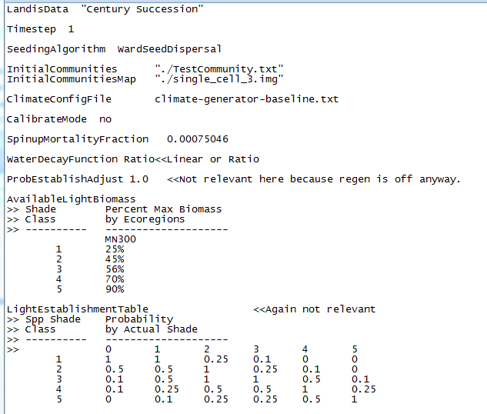

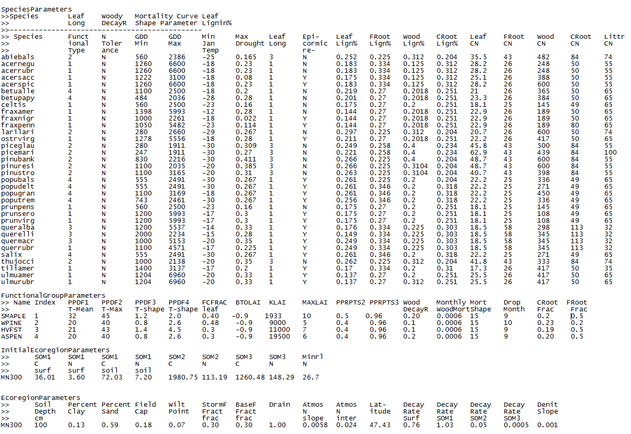 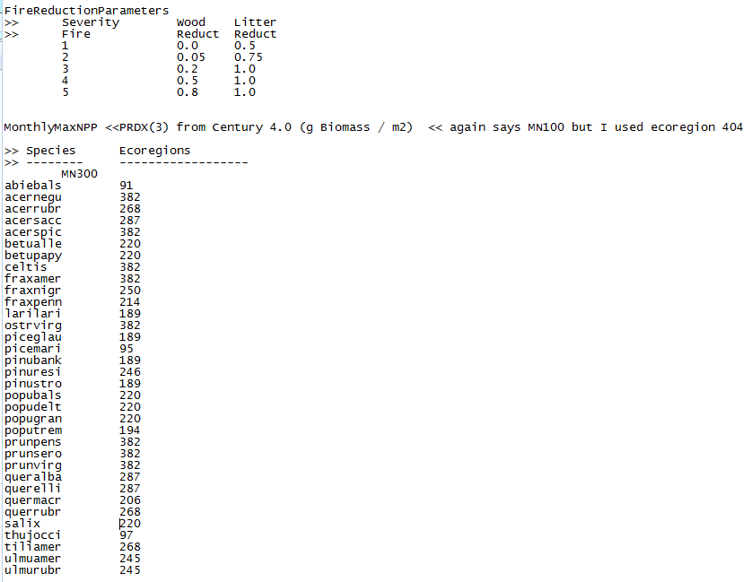

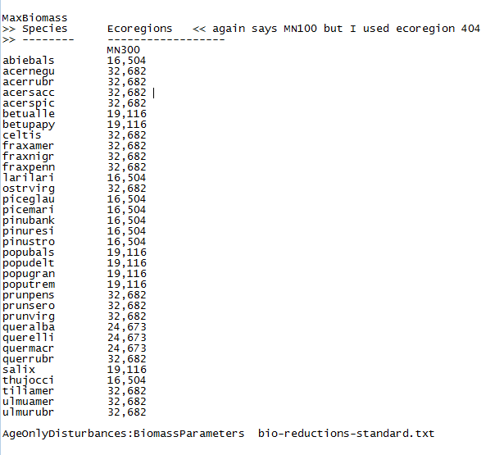

## Age-only Disturbances

